<2025 Bilateral International Collaboration Program for Arts & Culture>
“Kore•A•Round Culture”
Project Guidelines for Open call

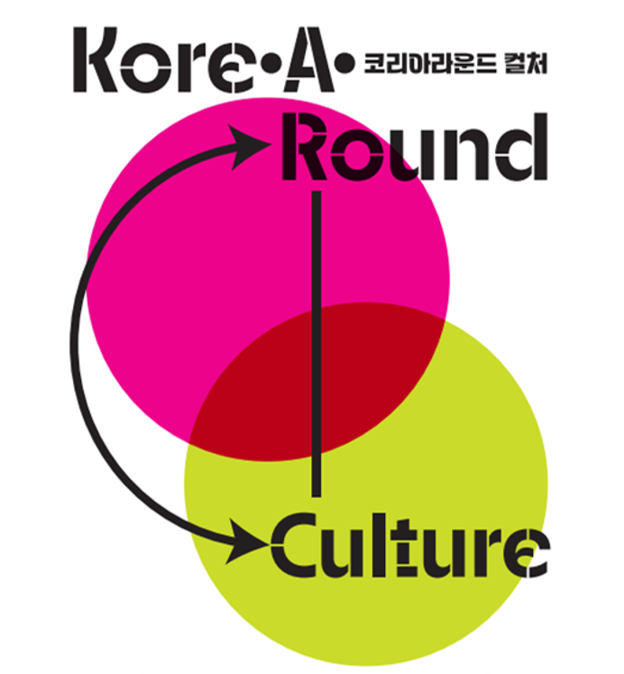

"Kore·A·Round Culture" is a Bilateral International Collaboration Program for Arts & Culture implemented by the Ministry of Culture, Sports and Tourism and the Korean Foundation for International Cultural Exchange (KOFICE).

This program aims to promote collaboration between Korean and international cultural organizations, establishing a sustainable foundation for global cultural exchange.

The project facilitates both inbound and outbound exchanges and partnerships between Korea and partner countries, supporting cultural organizations and artists in developing innovative cultural projects through collaborative efforts.

 | 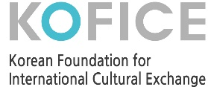

1. Introduction to 2025 Kore·A·Round Culture

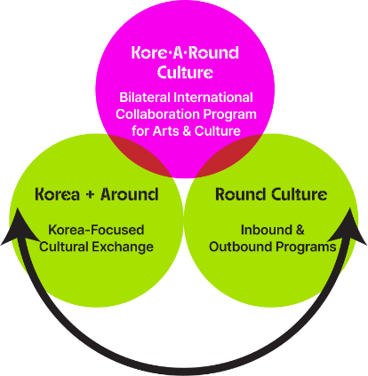 | The name of the project, “Kore•A•Round Culture,” combines “Round Culture”, which refers to the hosting of both inbound and outbound events, with “Korea+Around,” which suggests cultural exchanges centered around Korea. In this way, it signifies a program aimed at supporting bilateral cultural collaboration.

2. How “Kore·A·Round Culture” Changes in 2025
Category | 2024 | → | 2025
Selection | Evaluate and select participants by conducting a survey of demand through diplomatic offices | → | International arts and culture organizations/institutions/associations directly apply for “Kore•A•Round Culture” through an “open call.” This is to respect artists’ creativity and cultural diversity.
Content of the Project | Hosting outbound events is not mandatory. | → | “Hosting outbound events is mandatory.” This is to ensure bilateral cultural collaboration.
Personal Expense | Personal expense was only indicated as a percentage (20% of the project cost) (cf. 80%: government subsidies) | → | Personal expense is indicated as “specific items” (clarification of personal expense items in the project cost)
Support for Outbound Events | No government subsidies for Korean partner organizations in case of outbound events | → | Active support for outbound events by providing “Korean artists’ airfare and freight charge.”

3. Kore·A·Round Culture Supporting Bilateral Collaboration in 2025
Category | Items of Financial Support | Items of Expense for Participating Organizations/Institutions/Associations
Inbound  (in Korea) | * Expenses for hosting projects in Korea  ·Honorarium for Korean artists  · Airfare, accommodation and transport for international artists  · Venue/system rental  · Interpreting/translation  · Promotional activities, production of sourcebooks, etc. | · Honorarium for international artists  · All the other expenses including visa application fees for traveling to Korea
Outbound  (in the Partner Country) | * Korean artists’ airfare and freight charge in case of hosting outbound events (only within 15% of the financial support) | * Korean artists’ airfare and freight charge not covered by financial support for outbound events + all the other expenses

1 | Outline of the Project

(Project Name) Bilateral International Collaboration Program for Arts & Culture 2025 (Kore·A·Round Culture)
(Hosted by) Ministry of Culture, Sports and Tourism of the Republic of Korea
(Organized by) KOFICE
(Purpose) To encourage collaboration between Korean and international arts and culture organizations and to form a basis for sustainable exchange
(What to Support) Financial support for inbound and outbound arts and culture projects led by international arts and culture organizations/ institutions/associations
(Maximum Amount of Support) Up to 100 million won for each project
(Number of Projects to Support) About ten projects
*subject to change in accordance with the project budget and circumstances regarding applications

2 | Outline of the Open Call

(Title of the Open Call) Open call for 2025 Kore·A·Round Culture
Period and Process of the Open Call-------------------------- *based on KST
1) Open Call |  | Thurs, Dec 26, 2024 to Fri, Jan 31, 2025
2) Evaluation and Selection |  | Mon, Feb 3, 2025 to Fri, Feb 14, 2025
3) Announcement of the Selected Applicants and Negotiation/Confirmation of the Project/Signing of an MOU for Cooperation |  | Mon, Feb 17, 2025 to Fri, Feb 28, 2025
4) Implementation of the Project |  | Mar 2025 to the date of project closure
*subject to change in accordance with circumstances regarding the open call

(How to Apply) Please fill out the application form^{[Annex1]} and send it to us by email (karc@kofice.or.kr).
3 | Eligibility and Criteria of Applicants

(Eligibility) Arts and culture organizations/institutions/associations located in countries that have a Korean cultural center or a Korean cultural promotion center.^{[Annex2]}
(Fields) Literature, tradition, theater, dance, music, visual arts, craft/design and multidisciplinary art
(How to Collaborate) Bilateral collaboration between Korean and international organizations Joint creation/production/presentation of works Exchange between festivals, Other proposals
(Project Period) Inbound events will take place in 2025 and outbound ones, during the first half of 2026.
1. Inbound Events (in Korea)
- Period: During the year 2025
- Content: Collaboration with the partner country’s arts and culture organizations/ institutions/associations in Korea
- Examples: (Joint Planning/Creation/Production) Staging or exhibition of the two countries’ jointly created and produced works in Korea (Exchange between the Two Countries’ Events) Exchange between the two countries’ festivals and exhibitions, planning of the “week of the partner country” during a Korean festival (+inviting performances/exhibitions to Korea) (Others) Other proposals for bilateral collaboration

2. Outbound Events (in the Partner Country)
- Period: From the year 2025 to the first half of 2026
- Content: Collaboration with the partner country’s arts and culture organizations/ institutions/associations in the partner country
- Examples: (Exchange between the Two Countries’ Events) Exchange between the two countries’ festivals and exhibitions, planning of the “week of Korea” during the partner country’s festival (+inviting Korean performances/exhibitions to the partner country) (Others) Other proposals for bilateral collaboration
◆ Exemplary Cases of Bilateral Collaboration in 2024 ◆
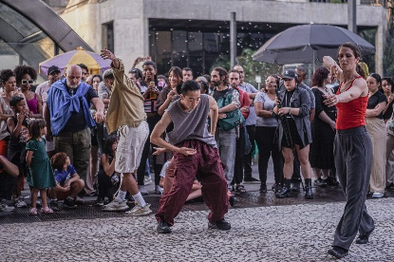 | - <Rotas Afora>  : Korea-Brazil Dance Collaboration  - Through a residency-based collaboration, the two countries’ dancers jointly created a performance telling a story of an urban space. The contemporary dance invigorated a symbolic place in Busan, Korea.
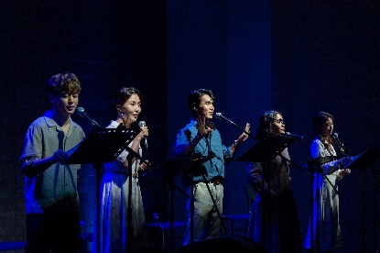 | - <Jessie’s Diary>  : Korea-China Musical Theater Collaboration  - A Korean couple fighting for their country’s independence keep a diary in China. The diary tells us how their daughter Jessie is growing up and how the couple’s independence movement is making progress. The musical is also about how a Chinese citizen contributes to the independence of the Republic of Korea. Korean and Chinese musical theater performers collaborated to re-create the story.
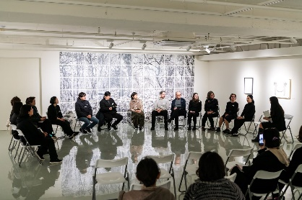 | - <You To Me, Me To You>  : Korea-Canada Printmaking Collaboration  - The project gathered together 24 printmakers from Korea and Canada. Focusing on the coexistence of “me and the other” and “you and me,” they exchanged, reinterpreted and modified their works. And finally, they completed their collaborative work and they exhibited it.

※ To ensure bilateral collaboration between Korea and the partner country, it is mandatory to organize events in both countries. ※

Applicants planning events in just one country are not eligible for the bilateral collaboration.

4 | Details of Support

(Support Budget) Up to 100 million won for each project
*subject to change in accordance with the size of the project
(Number of Projects to Support) About ten projects
*subject to change in accordance with the project budget and circumstances regarding applications
(Support Items) Expenses for events in Korea (excluding the honorarium for international artists) Korean artists’ airfare and freight charge for outbound events in 2025 (within 15% of the financial support)
(Personal Expense) Inbound Event: Honorarium for international artists Outbound Event: Korean artists’ airfare and freight charge not covered by financial support + all the other expenses Outbound Event (first half of 2026): All expenses
Category | Items of Financial Support | Items of Expense for Participating Organizations/Institutions/Associations
Inbound  (in Korea) | * Expense for hosting projects in Korea  · Honorarium for Korean artists  · Airfare, accommodation and transport for international artists  · Venue/system rental  · Interpreting/translation  · Promotional activities, production of sourcebooks, etc. | · Honorarium for international artists  · All the other expenses including visa application fees for traveling to Korea
Outbound  (in Partner Country) | * Korean artists’ airfare and freight charge in case of hosting outbound events (only within 15% of the financial support) | * Korean artists’ airfare and freight charge not covered by financial support for outbound events + all the other expenses

5 | Remark

Please read the following instructions carefully in order to prevent any disadvantage.
1. Applicants planning events only in one country are not eligible for the bilateral collaboration.
☞ It is mandatory to conduct the project in both countries.

2.. Once a project is selected for financial support, it needs to be carried out not only in the form of joint creation/production but also as inbound and outbound events.

3. The amount of financial support can be used only during the year 2025. As for projects starting in 2026, participants can carry them out at their own expense.

4. Outbound events are planned for the first half of 2026. If Korean and international partner organizations don’t implement them during this period, they may not be able to participate in other projects supported by KOFICE later on.
☞ An exception could be made for participants facing force majeure events. Such a case requires an additional discussion.

5. Projects that will be supported by other Korean institutions in 2025 are not eligible for Kore·A·Round Culture. If such a fact is found even later, their selection will be canceled. Put differently, organizations cannot apply for financial support from more than one Korean institution.

6. Profits made from Kore·A·Round Culture can only be used for the expenses of hosting outbound events.

6 | Criteria for Evaluation

(Evaluation Committee) At least five persons from outside (including international cultural exchange experts) will form an evaluation committee.
(Evaluation Sections) Project implementation and cooperation plans (50 points), Budget execution plan and capacity (30 points), Sustainability and ripple effects (20 points)
Section | Evaluation Criteria | Point
Project implementation and cooperation plans  (50 points) | ◌ Capacity to plan a project, concreteness of the plan and its feasibility  ◌ Appropriateness of the scope of the project in light of its goal  ◌ Appropriateness of the programming of the event  ◌ Period/concreteness of the outbound project | 30
Project implementation and cooperation plans  (50 points) | ◌ Appropriateness, feasibility and trustworthiness of the plan to invite Korean and international organizations/ institutions/associations  ◌ Artistic excellence and domestic/international profile of the Korean/international organizations/institutions/ associations to be invited  ◌ Ripple effects and attractiveness of the collaborative program | 20
Execution plan and capacity  (30 points) | ◌ Appropriateness and reasonableness of budget distribution and the budget execution plan  ◌ Possibility of expanding the scope of the project to activities not covered by the current budget | 20
Execution plan and capacity  (30 points) | ◌ Professionalism, management capacity and relevant past activities of the organization/institution/association regarding the project | 10
Sustainability and ripple effects  (20 points) | ◌ Degree of contribution to improving cultural diversity in the organization’s country  ◌ Degree of contribution to helping the Korean arts and culture go global  ◌ Ripple effects of the project on the growth of bilateral cultural collaboration | 20
Planning of outbound events | ◌ Points will be added for projects including a plan to host outbound events in 2025. | -
Total |  | 100

7 | Information and Inquiries

(Website) www.korearoundculture.com
(Inquiries) Kore·A·Round Culture Team at KOFICE
- (Tel) +82(0)2-3150-4848, 4849, 4850
- (Email) karc@kofice.or.kr

Annexes | - Application form
 | 2. Countries that have Korean diplomatic offices (Korean cultural center/Korean cultural promotion center)

Annex 1 | Application Form
Bilateral International Collaboration Program for Arts & Culture
<2025 Kore·A·Round Culture>
Name of Organization
Name of Applicant |  | (Sign or Seal)
*Provide the name of the contact key permanent artistic or administrative staff person responsible for this application.
Country/City |  |  |  |  | Email
Telephone Number |  |  |  |  | Mobile Number
Project Title |  | (Korean)  (English)
*The name you provide is for your reference and will identify this grant application.
Project  in Korea  (inbound)  *Required |  | Period of Project
 |  | Venue/City
 |  | Main contents
Project  in abroad  (outbound)  *Required |  | Period
 |  | Venue
 |  | Main contents
Artform of Project |  | Literature Traditional Art Theater Dance Music  Visual Arts Craft/Design Multidisciplinary Art or Other ( )
* Projects supported by other Korean public institutions are not eligible for this grant program.

* If it is confirmed that an identical or similar project has been submitted to other Korean public institutions for support, the application will be canceled.
- I hereby declare that the information provided in the application is true and correct. ☑
- I authorize KOFICE to disclose information provided in this application to the public for project evaluation, review of duplicate funding by other Korean institutions, and public purposes. ☑
1. Project Implementation and Collaboration Plan (50%)
A. Applicant Information
Collaboration Type |  | Co-create new projects  Collaborate on events in applicant’s country and Korea (festivals, exhibitions, etc.)  Others
Name of Organization |  | Korean
 |  | English
Organization Type |  | Provide the information of applicant’s organization:  Artistic groups, arts organization, festival organizer, educational institution, etc.
Phone
Email
Website |  | or social media, other online promotional channels
Introduction of Organization |  | - Field of activities  - members  - awards, etc.
B. Korean Partner Information
Name of Organization |  | Korean
 |  | English
Organization Type |  | Provide the information of Korean partner:  Artistic groups, arts organization, festival organizer, educational institution, etc.
Phone
Email
Website |  | or social media, other online promotional channels
Introduction of Organization |  | - Field of activities  - members  - awards, etc.

C. Plan for Project in Korea and in Partner Country
Project Description | * Describe your collaboration project taking place in South Korea in 2025.  - Write every detail and information on the event; date, venue, goals, funding plan, artists, details of collaboration, roles, methods of delivery, etc.  *Describe your collaboration project taking place in your country in 2025 or during the first half of 2026.  - Write every detail and information on the event; date, venue, goals, funding plan, artists, details of collaboration, roles, methods of delivery, etc.

2. Feasibility of Budget/Capacity of Applicant (30%)
D. Budget/Program Expenses *Funding budget will be confirmed through MOU after selection.
1 Budget for Project in Korea (Total Amount: KRW____________ )
 |  | Budget |  | Total
Covered by KOFICE |  | *Applicant can apply for a grant of up to KRW100,000,000  (e.g.) Please provide details of expenses in KRW.  - Venue rental: KRW10,000,000  - System rental: KRW30,000,000  - Korean Artists fee: KRW8,000,000  - Artists and staff airfare: KRW20,000,000  - Artist accommodation: KRW4,000,000 (for 8 people/5 days)  - Interpreting/Translation: KRW5,000,000  - Archiving (book, video, etc.): KRW10,000,000 |  | KRW 00,000,000
Covered by Applicant |  | (e.g.) Please provide details of expenses in KRW.  - International Artists fee: KRW8,000,000  - Visa fee: KRW100,000 |  | KRW 00,000,000
2 Budget for Project in Partner Country (Total Amount: KRW____________ )
 |  | Budget |  | Total
Covered by KOFICE |  | *Applicant can use 15% of the financial support provided by KOFICE.  *This amount can be used only for Korean artists’ airfare and freight charge as they travel to your country.  (e.g.) Please provide details of expenses in KRW.  - Korean Artists airfare: KRW8,000,000  - Korean Artists freight charge: KRW2,000,000 |  | KRW 00,000,000
Covered by Applicant |  | (e.g.) Please provide details of expenses in KRW.  - Artist fee: KRW10,000,000  - System rental: KRW3,000,000  - Artist accommodation: KRW4,000,000  -Archiving: KRW10,000,000 |  | KRW 00,000,000
E. Key Achievements of Applicant and Korean Partner (2022-2024)
Year | Project Name |  | Achievements
 |  |  | - Date, location, roles, number of participants, media coverage, awards, references, websites, etc.
- Please do not add images here.
- If you want to submit images or additional documents, attach a PDF file in your email of application.

3. Sustainability and Ripple Effects (20%)
F. Expected outcomes of the collaboration
Describe the impact and expected outcomes of the international cultural exchange between your country and Korea.
G. Project Plan in Applicant’s Country
Describe your collaboration project taking place in your country in 2025 and during the first half of 2026.
- Project details (date, venue, goals, funding plan, artists, details of collaboration, roles, methods of delivery, etc.)

Annex 2 | List of Korean Cultural Center/Korean Cultural promotion center
Category |  | Region | Country
Korean Cultural Center |  | Europe | Germany
 |  | Europe | Russia
 |  | Europe | Belgium
 |  | Europe | Spain
 |  | Europe | United Kingdom
 |  | Europe | Austria
 |  | Europe | Italia
 |  | Europe | Poland
 |  | Europe | France
 |  | Europe | Hungary
 |  | Europe | Sweden
 |  | America | Canada
 |  | America | United States – New York
 |  | America | United States – Washington, DC
 |  | America | United States – Los Angeles
 |  | America | Mexico
 |  | America | Brazil
 |  | America | Argentina
 |  | Asia | Vietnam
 |  | Asia | Australia
 |  | Asia | Japan – Tokyo
 |  | Asia | Japan – Osaka
 |  | Asia | Indonesia
 |  | Asia | India
 |  | Asia | China – Beijing
 |  | Asia | China – Shanghai
 |  | Asia | Hong Kong
 |  | Asia | Kazakhstan
 |  | Asia | Thailand
 |  | Asia | Philippine
 |  | Sub-Middle East | Nigeria
 |  | Sub-Middle East | South Africa
 |  | Sub-Middle East | UAE
 |  | Sub-Middle East | Egypt
 |  | Sub-Middle East | Türkiye
Korean Cultural Promotion Center |  | Europe | Czech Republic
 |  | America | United States- New York
 |  | Asia | Malaysia
 |  | Asia | Singapore
 |  | Asia | Japan – Tokyo
 |  | Asia | China – Beijing
 |  | Sub-Middle East | Iran

